**IFT 266 Introduction to Network Information Communication Technology (ICT)   
  
Lab 40**

**Using the CLI to Create IPV6 Link-Local, GUA’s, Subnets, and Auto Configure their PC’s**Co-authored by Paul Polsinelli

Choose from the list of commands from the bottom of the page and put them in the right order by typing them in the proper box.

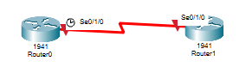

1. Enable ipv6 unicast-routing and link-local addresses on two router serial connections.

**Router0**

enable

Router>

Configure terminal

Router#

Ipv6 unicast-routing

Router (config)#

Interface s0/1/0

Router (config)#

Ipv6 address fe80::1 link-local

Router (config-if)#

No shutdown

Router (config-if)#

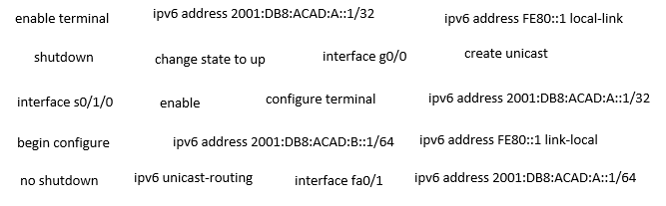

**Router1**

enable

Router>

Configure terminal

Router#

Ipv6 unicast-routing

Router (config)#

Interface s0/1/0

Router (config)#

Ipv6 address fe80::1 link-local

Router (config-if)#

No shutdown

Router (config-if)#



1. Create the topology in packet tracer and input the commands you selected above.   
     
   Your topology should now look like the following image

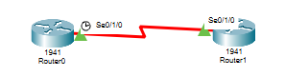





1. We will now add 2 switches and 2 PCs to our topology.

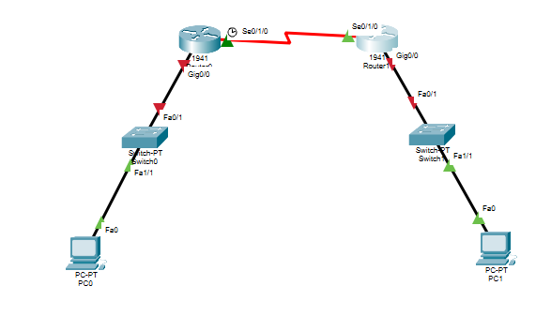



1. Enable ipv6 link-local addresses on two router gigabit connections.

**Router0**

enable

Router>

Configure terminal

Router#

Interface g0/0

Router (config)#

Ipv6 address fe80::1 link-local

Router (config-if)#

No shutdown

Router (config-if)#



**Router1**

enable

Router>

Configure terminal

Router#

Interface g0/0

Router (config)#

Ipv6 address fe80::1 link-local

Router (config-if)#

No shutdown

Router (config-if)#



1. Input the commands in packet tracer.



1. Your topology should now look like the following image.

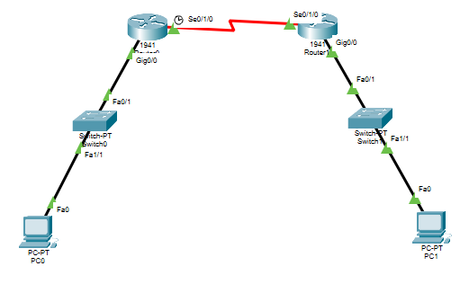



1. Now we will configure the routers with Global Unicast Addresses (GUA)s.

**Router0**

enable

Router>

Configure terminal

Router#

Interface g0/0

Router (config)#

Ipv6 address 2001:DB8:ACAD:A::1/64

Router (config-if)#

No shutdown

Router (config-if)#



**Router1**

enable

Router>

Configure terminal

Router#

Interface g0/0

Router (config)#

Ipv6 address 2001:DB8:ACAD:B::1/64

Router (config-if)#

No shutdown

Router (config-if)#



1. Input the commands in packet tracer.



1. You should now be able to Auto Config the PC’s.   
     
   The fields IPv6 Address, Link Local Address, and IPv6 Gateway should automatically populate.   
     
   Do this autoconfiguration for PC1, then take a screenshot and insert below.

